**Dual-structure features for heavy ion and light particles**

Kolokolchikov S.1, Senichev Yu. 1, Aksentyev A. 1,2, Melnikov A. 1,3

1Institute for Nuclear Research of the Russian Academy of Sciences, Moscow, Russia

2National Research Nuclear University MEPhI, Moscow, Russia

3Landau Institute for Theoretical Physics, Chernogolovka, Russia

**Abstract**

The NICA collider will be used for both collider experiments with heavy ions and light polarized nuclei. The different charge-to-mass ratio is essential in magneto-optics design. To achieve high luminosity sufficient beam lifetime must be guaranteed. Transition energy crossing must also be solved.

**Introduction**

Regardless of the purpose of the synchrotron, always in the case of two modes, when multiply charged heavy particles and one or two charged light particles are accelerated, the problem arises of what the magneto-optical structure should look like to satisfy all the conditions of stable motion for both types of particles. Obviously, compared to light particles, multiply charged particles have a prevailing heating effect due to intra-beam scattering, and light particles have a greater chance of crossing through transition energy. All these effects are of great importance for colliders, where luminosity plays a decisive role. When developing a structure that meets all the requirements for differently charged particles, it is fundamentally important to have a retunable structure without introducing design differences. We called such a structure dual.

In NICA complex the dual magneto-optical structure opens up the prospect of accelerating both heavy ions, such as gold, and light particles like protons and deuterons. The design of this structure requires a different approach due to the varying charge-to-mass ratios involved.

1. **Light particles mode**

In a classical regular structure, the transition energy is approximately equal to the betatron tune [1]. For the same magnetic rigidity , the maximum energy for light particles is greater than for heavy ions due to their charge-to-mass ratio. This means that a heavy-ion structure optimized for operating up to a certain transition energy would require overcoming that energy in order to operate with light particles. For this reason, a structure with varying transition energy can be considered.

* 1. **Transition Energy**

In general, the transition energy is determined by the momentum compaction factor

where – orbit length, – dispersion function, – radius of orbit curvature. It is a characteristic of the structure and remains constant regardless of the particle type. In the first order the slip-factor , and thus the frequency of synchrotron oscillations tends to zero when the beam energy approaches the transition value. In this case, the adiabaticity of the longitudinal phase motion is violated, which leads to instabilities, as well as the influence of nonlinear effect higher orders of momentum spread . The introduction of modulation into the or , function leads to variations in the momentum compaction factor and, consequently, the transition energy.

* 1. **Superperiodic modulation**

The equation for the dispersion function with biperiodic variable focusing [2]

, (2)

where , ,  *–* gradient of magneto-optical lenses, – superperiodic gradient modulation. Here is considered an additional perturbation to regular one , where –-th harmonic of the gradient modulation in the Fourier series expansion of the function. The solution for momentum compaction factor as follows

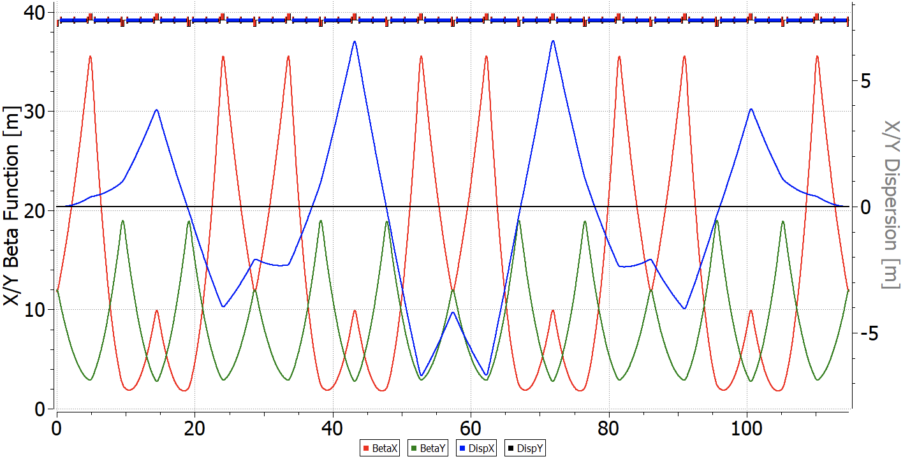where – the average value of the curvature, – betatron tune in horizontal plane on arc, – number of superperiods per arc length. Eq. (3) considered without introducing curvature modulation due to the possibility of introducing a variation of transition energy into a stationary lattice. To raise the transition energy, it is necessary to reduce , this means that the expression under the sum sign must be negative, this is realizable under the condition . First harmonic has a dominant influence the condition is implemented for , . Figure 1 shows 12 FODO cells per arc, 3 FODO cells are combined into one superperiod [3]. Thus, due to the tune of betatron tune a multiple of , the arc has the properties of a first-order achromat. For structure with the missing magnet technique introduced for one reason or another it can be also implemented (Fig. 2), but need to suppress dispersion at the edge of arc [4].

Fig 1. "Resonant" magneto-optic structure with dispersion modulation and increased transition energy.

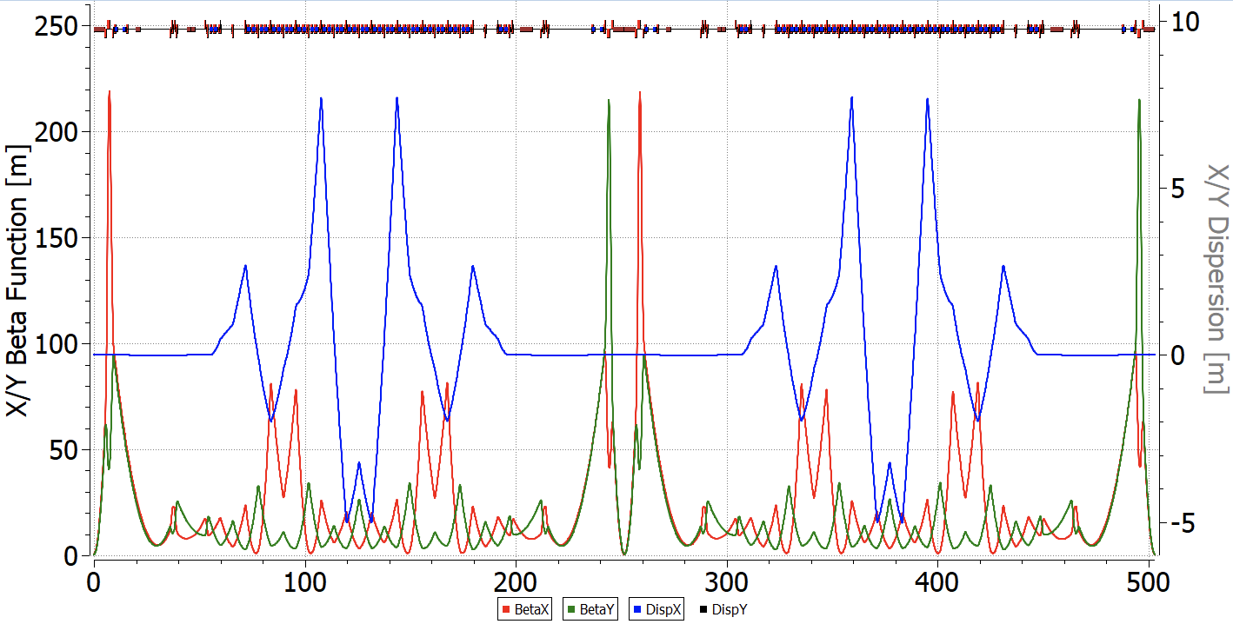

Fig. 2 "Resonant" NICA magneto-optic adapted structure with increased transition energy and missing magnet

1. **Structure for heavy ions**

The lifetime of the beam luminosity in a collider experiment is achieved through the reduction of intra-beam scattering effects, coupled with the application of stochastic and electron beam cooling techniques. This approach assumes particular significance when dealing with high-intensity ion beams. The temporal evolution of emittance and momentum spread in the presence of cooling processes is governed by a set of equations

where – transverse emittance, – transverse cooling time, – momentum spread, – longitudinal cooling time.

For time-independent, stationary values, the time derivatives become zero, then

The benchmark for evaluating the effectiveness of a cooling technique can be determined by comparing the timescales of stochastic or electron cooling processes to the beam lifetime due to IBS over the entire energy spectrum.

* 1. **Stochastic cooling**

Let's consider stochastic cooling using the approximate theory developed by D.Mohl [5, 6]. Based on his main findings, the cooling rate can be determined using the following expression

where – system bandwidth, – effective number of particles, recalculated based on the ratio of orbit length to the beam length, considering its distribution, – fraction of observed sample error corrected per turn, – the ratio of noise to signal, *,* – mixing factors between the pickup-kicker and the kicker-pickup, respectively. Equation (6) in the absence of noise at reaches the maximum

The mixing coefficients are defined as

where – relative particle displacement times (mixing),  – slip-factor, as a first approximation , – first-order of local momentum compaction factors, – the absolute times between the pickup-kicker and kicker-pickup, respectively. The stochastic cooling times of eqs. (7-8) depend on the ratio of the effective particle density to the cooling system bandwidth and the properties of magneto-optics, local momentum compaction factors .

The maximum value of the frequency band is determined by the requirement that the "Schottky" beam bands do not overlap. In the simplest case, this can be expressed:

thus, a mixing factor . Otherwise, the cooling efficiency becomes zero. Thus, for a given number of particles, it is desirable to achieve the highest possible frequency band. From an electron perspective, modern technologies allow for the implementation of a 10 GHz frequency band [7], however, its use is not always feasible due to the large magnitude of the slip-factor and momentum spread .

Equation (6) has been derived for coasting beam. Particle density for a single harmonic RF resonator is described by a Gaussian distribution

where – the distance from the beam center, – the dispersion of the particle distribution, and – the number of particles. Assuming that cooling is at its minimum at the center (), the effective particle number at orbit length can be calculated as follows:

For a beam generated by a multiharmonic barrier-type RF system, so-called "Barrier Bucket", the particles distribution in the beam can be considered approximately uniform along its entire length. The effective particles number is determined by a simple ratio of the beam length to the total orbit length:

To summarize, the effective value of particles depends on their distribution and is determined by their form-factor

As example let us consider the case of NICA with maximal form-factor with m, m, . Considering the accumulated FNAL [8] experience, quite realistic values for the frequency band are GHz and GHz. For NICA GHz and GHz. With these parameters, the maximum achievable cooling rate is .

Based on equations 9-10, it is evident that asymptotic growth may occur in two scenarios:

1. the slip-factor approaches the value , the beam Schottky spectrum becomes continuous and ;
2. slip-factor approaches zero, mixing between the kicker to the pickup does not occur and .

The efficiency of stochastic cooling depends on the properties of magneto-optical structure. In classical “*regular”* structures, transition energy is acquired through the horizontal frequency and slip-factor can achieve zero. To avoid asymptotic growth, it is necessary to vary the slip-factor which means . This is possible in “*resonant*” structure, where transition energy can be increased or even reach complex value. In more exotic case, can be used “*combined*” structure then (pickup-kicker) with real transition energy at one arc

compensated by (kicker-pickup) with complex transition energy at another

for the whole ring. Such structure achieves the required ratio of mixing factors for a maximum cooling rate close to ideal [9]. Let us delve deeper declared structures in more detail.

The behaviour of the -functions and the dispersion across the entire “*regular*” ring illustrates at Fig. 3. The straight sections, which remain constant in all structures, are essential for analyzing of the resonant characteristics of the entire structure. Their arrangement does not affect the intra-beam scattering and transition energy. To suppress dispersion in the “*regular*” structure, ‘missing magnets’ technic implemented on both sides of the arc.

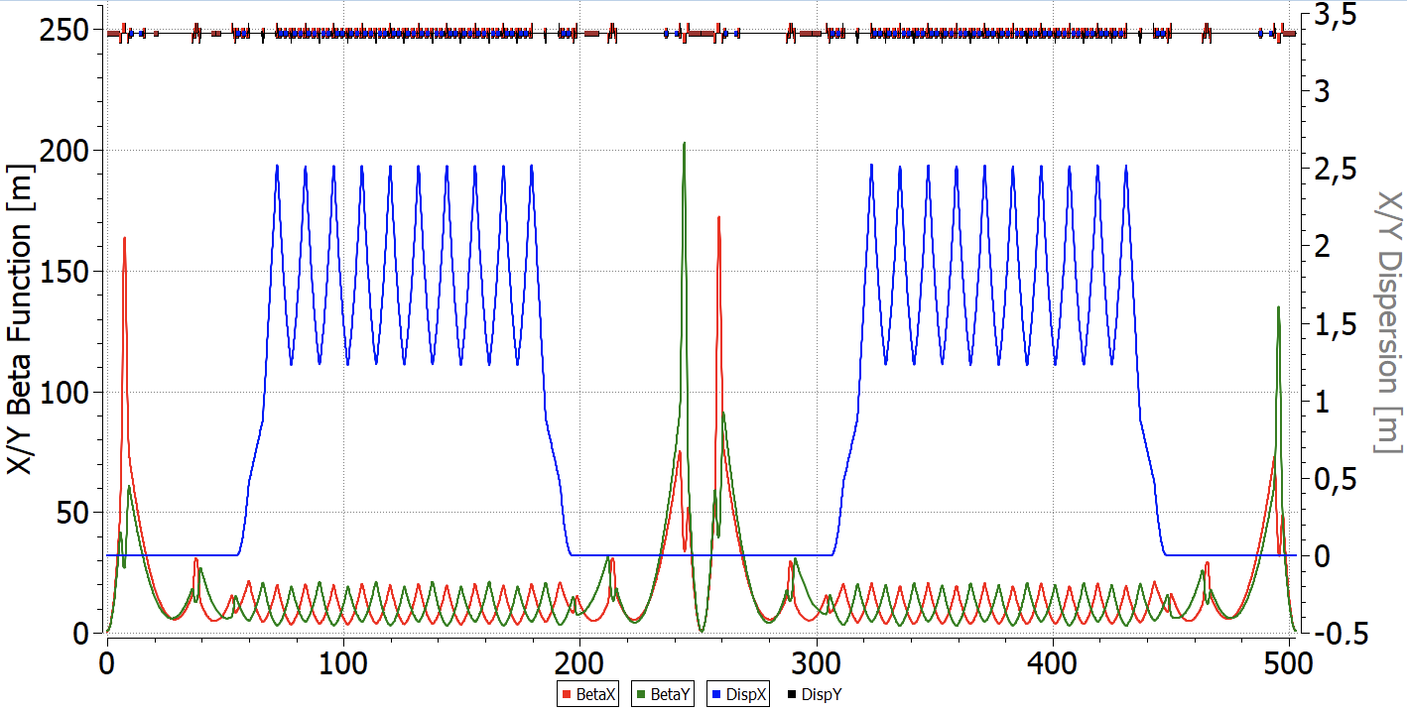

Fig. 3 “Regular” FODO NICA magneto-optic structure with missing magnets.

The “*resonant*” structure is based on the principle of resonant modulation of the dispersion function and can be obtained from a "*regular*" one by introducing additional family of focusing quadrupoles. To suppress dispersion can be used either two edge focusing quadrupoles on both sides of the arc or only two families of focusing quadrupoles on the arc, when an integer number of betatron oscillations is reached.

In the case of a “*combined*” structure, one arc operates in a regular mode, while the other employs resonant modulation (Fig. 4). Such choice is based on the principle of compensation, as described by eqs. 13 and 14, which requires a greater modulation depth of the quadrupoles than in purely "*resonant*" structure with increased transition energy.

As illustrated in Figure 5, "*resonant*" optics with increased transition energy, the second asymptotic is at higher energy compared to the “*regular”* structure. In “*combined*” magneto-optics, the cooling efficiency is closer to the ideal value in a large energy range from to GeV, while in “*regular”* optics the cooling rate is almost two times lower at the most optimal point GeV. This behaviour is explained by absence of the second point of asymptotic growth.

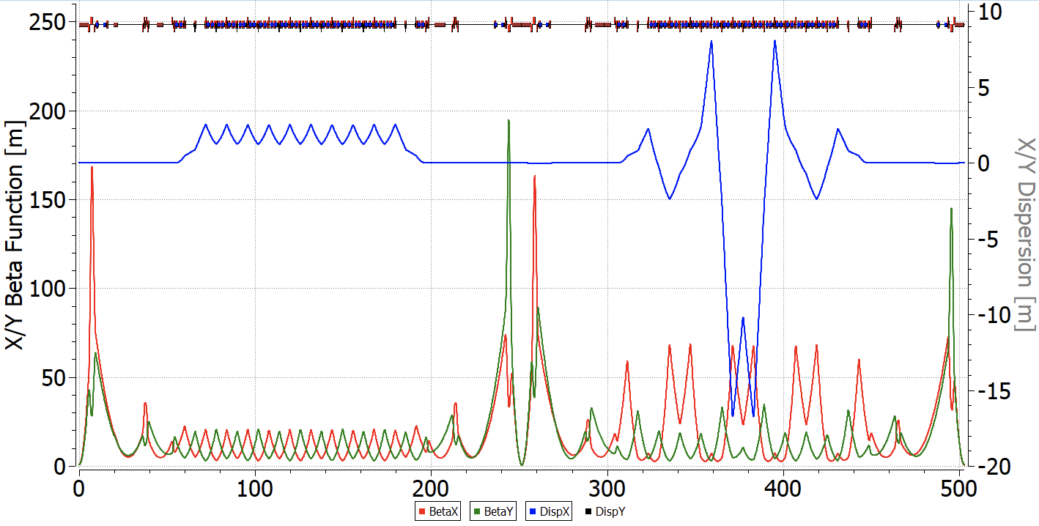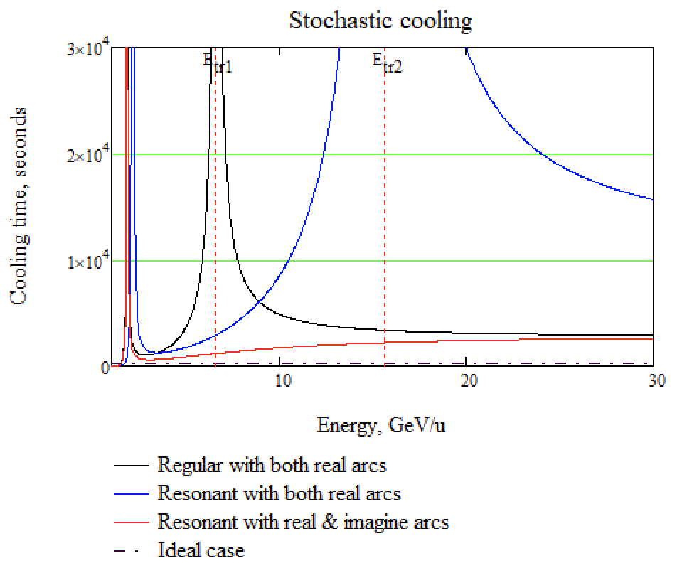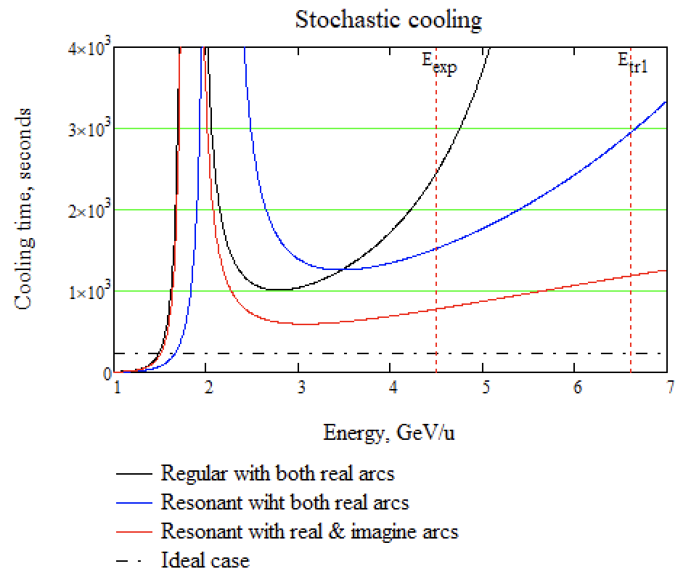

Fig. 5 The dependence of stochastic cooling time on the energy for various structures.

Fig. 4 "Combined" NICA magneto-optic structure with real and complex transition energies in arcs.

* 1. **Intrabeam Scattering**

Intra-beam scattering represents a fundamental limitation on the beam lifetime in the collider. Consequently, the selection of an appropriate cooling technique hinges on comparing its characteristic time scales with the rate at which the beam is heated due to intra-beam scattering. This is derived from the fundamental principles governing this process

Unlike stochastic cooling, the IBS rate increases as decreasing energy . In addition, the expression in parentheses is proportional to the slip-factor . Therefore, it should be expected that in optics with a value close to zero, the heating rate should decrease. Figure 6 shows the dependences of the heating time constant in the three above-mentioned structures calculated using MADX programs [10] for the parameters of the heavy ion beam of the NICA collider with maximum luminosity . In the context of light nuclei, such as protons and deuterons, the IBS time experiences a significant increase as the charge decreases. Consequently, the issue of intra-beam scattering becomes critical for heavy-ion beam.

From the comparison of the IBS lifetime with the cooling time it can be concluded that in a regular structure, stochastic cooling is able to balance intra-beam scattering in the energy range GeV. In order to apply stochastic cooling over the entire energy range, it is obvious that we must sacrifice the luminosity of the beam at low energies by increasing the emittance. In resonant structures, the IBS time is notably reduced. This is explained by the fact that the structure has a greater ratio between the dispersion and the beam -function than in the case of a regular. Thus, for the case of heavy ions, the configuration should be regular and minimally modulated. Electron cooling is used in the regular structure to cool the beam lower 4.5 GeV [11, 12].

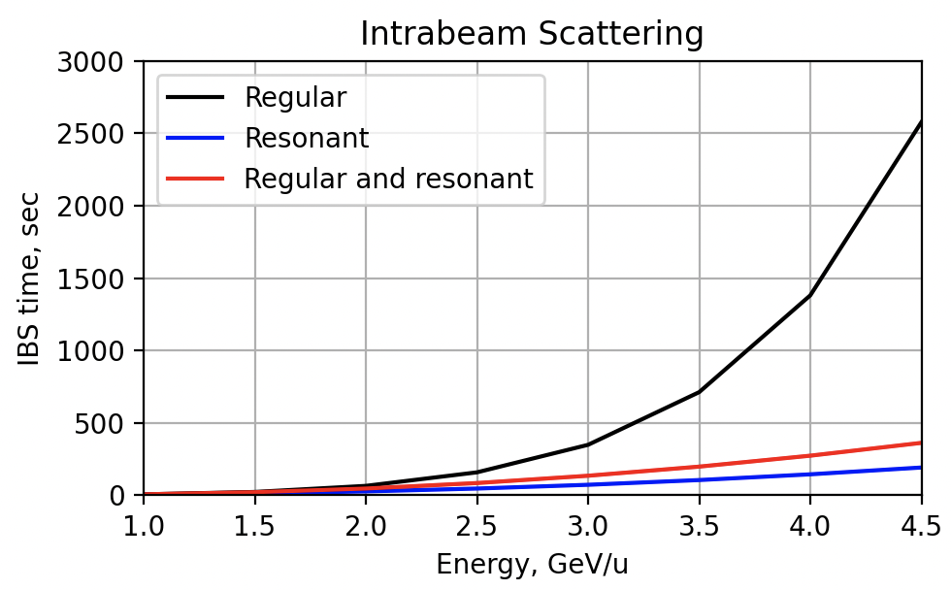

Fig. 6 The dependence of the beam lifetime due to intra-beam scattering in “regular”, "resonant" and “combined” structures on the beam energy for heavy ion beam.

Table 1. Main parameters for various structures.

|  |  |  |  |
| --- | --- | --- | --- |
| Structure | Regular | Resonant | Combined |
| Particles |  |  |  |
| Experiment energy, *GeV*/u |  | 12.6 | 12.6 |
| Transition energy |  |  |  |
| Modulation depth | – | 25% | 45% |
| Cooling time at 4.5 GeV, s | 2500 | 1500 | 800 |
| IBS at 4.5 GeV, s | 2500 | 400 | 250 |

**Conclusion**

The dual magneto-optical structure is proposed for accelerating both heavy ion and light particle beams, exemplified by the NICA facility. For light particles, due to charge-to-mass ratio, experiment energy can rise more than transition energy of the lattice, which is optimal for heavy ions. Using dispersion modulation, transition energy increases or even reaches a complex value in a “*resonant*” magneto-optic structure. However, due to modulation of -function and dispersion, the time of intra-beam scattering decreases, which is crucial for multiply charged heavy particles. For this reason, a “*regular*” magneto-optic structure with minimally modulated dispersion and -function is optimal in the heavy-ion mode. Despite the fact that stochastic cooling in “*regular*” structures is significantly weaker than in “*resonant*” and “*combined*’ ones, it can compensate IBS effect.

No special changes are required to convert the “*regular*” structure into a “*resonant*” one. It is enough only to introduce a separate family of quadrupoles

**References**

1. Lee, Shyh-yuan, Accelerator Physics (Fourth Edition), World Scientific Publishing Company, 2018.
2. Senichev, Y.V., Chechenin, A.N. Theory of “Resonant” lattices for synchrotrons with negative momentum compaction factor. J. Exp. Theor. Phys. 105, 988–997 (2007). <https://doi.org/10.1134/S1063776107110118>
3. Senichev, Y.V., Chechenin, A.N. Construction of “resonant” magneto-optical lattices with controlled momentum compaction factor. J. Exp. Theor. Phys. 105, 1141–1156 (2007). <https://doi.org/10.1134/S1063776107120060>
4. Kolokolchikov, S.D., Senichev, Y.V. Magneto-Optical Structure of the NICA Collider with High Transition Energy. Phys. Atom. Nuclei 84, 1734–1742 (2021). <https://doi.org/10.1134/S1063778821100185>
5. D. Möhl, G. Petrucci, L. Thorndahl and S. van der Meer, Phys. Rep. 58 (1980) 75
6. D. Möhl, Nuclear Instruments and Methods in Physics Research A 391 (1997), 164-171
7. F.Caspers, D. Möhl , Stochastic Cooling in Hadron Colliders, Proc. of XVII International Conference High Energy Accelerators, 1998, Dubna
8. M. Church, Stochastic cooling in Fermilab, Nuclear Instruments and Methods in Physics Research A 391 (1997) 172-175.
9. Yu. Senichev, The advanced HESR lattice for improved stochastic cooling, American Institute of Physics, COOL-07 workshop, [Bad Kreuznach](http://www.bad-kreuznach-tourist.de/en/), Germany, 2007, <http://bel.gsi.de/cool07/TALKS/TUA2C07_TALK.PDF>
10. Antoniou, F., Zimmermann, F., Revision of Intrabeam Scattering with Non-Ultrarelativistic Corrections and Vertical Dispersion for MAD-X, CERN-ATS-2012-066.
11. С.А. Костромин и др., Применение методов охлаждения пучков в проекте NICA, Письма в ЭЧАЯ, 2012, Т.9. №4-5(174-175), C. 537-562.
12. Grigory Trubnikov, Anatoly Sidorin, Nikolay Shurkhno, NICA cooling program, CYBERNETICS AND PHYSICS, Vol. 3, No. 3. 2014, 137-146